The Tax Cuts and Jobs Act of 2017 and Your Federal Income Tax Return

By Edward Frede, Staff Accountant, Gelman & Pelesh, P.C.

The Tax Cuts and Jobs Act of 2017 (TCJA), enacted into law in December 2017, represents the most significant and comprehensive change to the federal tax code in over 30 years. Among its other provisions, the TCJA lowered income tax rates and effectively doubled the standard exemption for most individual taxpayers, while also reducing the corporate income tax rate from 35% to 21%. In this article, we will look at a few of the more significant changes made to the tax law by the TCJA, and consider the implication of these changes for your federal income tax return. While the emphasis of this article will be on the tax reporting requirements for individuals, we will also briefly mention several significant federal tax law changes affecting small businesses.

New Tax Forms

Perhaps a good place to start is by looking at the changes in the tax forms themselves. Two of the three versions of Form 1040 utilized during last year’s tax filing season – Form 1040A and Form 1040EZ – have been eliminated, so that all taxpayers filing their returns for 2018 will use a single, substantially revised version of Form 1040. The front and back of the new Form 1040 are shown below:

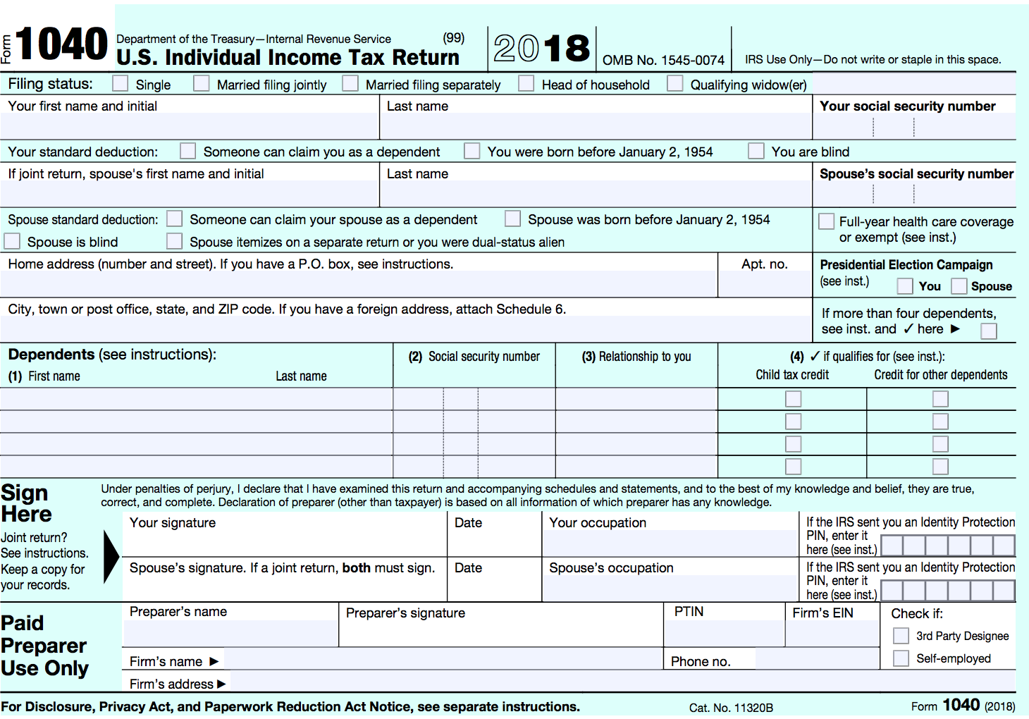

2018 Form 1040, front
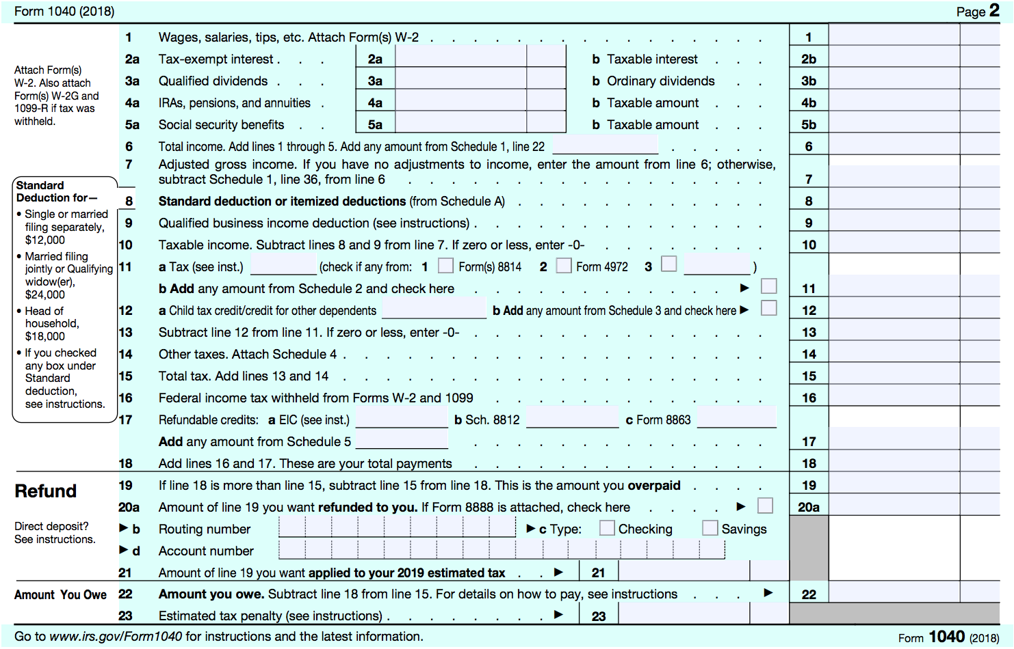

2018 Form 1040, back

The new Form 1040 takes up two half-pages, and is thus considerably shorter than the versions of Form 1040 in effect during last year’s tax season. Much of the information previously reported on Form 1040 has been moved to six new supporting forms (Schedules 1-6), however, so the task of tax preparation will not necessarily be simplified for taxpayers with more complex situations. Overall, clarity appears to have been sacrificed for the sake of brevity in the new Form 1040. For example, the form provides separate spaces for reporting income from wages, interest, dividends, IRAs, pensions, and Social Security benefits, but not for reporting business income, capital gains, partnership income, or alimony. Taxpayers will instead be required to enter the latter types of income on Schedule 1, and then enter the total for all items of income reported on Schedule 1 on Line 6 of Form 1040. Another confusing detail is that, while Form 1040 provides lines for reporting interest and dividend income, Form 1040 does not refer to Schedule B, which taxpayers must complete when they have more than $1,500 in income from taxable interest or ordinary dividends. Finally, the six new schedules to one side, the tax law changes have not led to a significant cutback in the amount of paperwork that taxpayers must complete: most of the supporting schedules and forms that were in effect during last year’s tax season – such as Schedule C, used to report business income, or Schedule D, used to report capital gains – are expected to remain in use in 2019.

While draft versions of the new Form 1040 and of the six supporting schedules were released by the IRS over the summer, the final versions of these forms were issued on December 14, 2018, and can now be accessed online at https://www.irs.gov/forms-pubs/about-form-1040.

New Tax Brackets and Rates

Although the number of tax brackets – seven – remains unchanged under the TCJA, most of the tax rates have changed, together with the income levels at which these rates apply. The old and new income tax brackets for the two most common filing statuses recognized under the U.S. Internal Revenue Code – single individuals and married taxpayers filing jointly – are shown below.

A noteworthy effect of the new tax brackets is that they reduce or eliminate the so-called “marriage penalty” for many couples where both spouses are middle- or high-income earners. How the marriage penalty worked under the old tax brackets can be seen in the fact that the income levels that placed spouses filing jointly into the 28% tax bracket ($153,101-$233,350) were less than twice as high as those for single filers subject to the 28% tax rate ($91,901-$191,650). Under the new tax brackets, by contrast, the income thresholds for married taxpayers who file jointly and who fall between the 12% and 32% brackets ($19,051-$400,000) are now roughly twice as high as those of single taxpayers falling between the same brackets ($9,526-$200,000).

Income Tax Brackets for Single Taxpayers – 2017 and 2018

2017 |  | 2018
Tax Rate | Taxable Income | Tax Rate | Taxable Income
10% | $0–$9,325 | 10% | $0–$9,525
15% | $9,326–$37,950 | 12% | $9,526–$38,700
25% | $37,951–$91,900 | 22% | $38,701–$82,500
28% | $91,901–$191,650 | 24% | $82,501–$157,500
33% | $191,651–$416,700 | 32% | $157,501–$200,000
35% | $416,701–$418,400 | 35% | $200,001–$500,000
39.6% | $418,401 or more | 37% | $500,001 or more

Income Tax Brackets for Married Taxpayers Filing Jointly – 2017 and 2018

2017 |  | 2018
Tax Rate | Taxable Income | Tax Rate | Taxable Income
10% | $0–$18,650 | 10% | $0–$19,050
15% | $18,651–$75,900 | 12% | $19,051–$77,400
25% | $75,901–$153,100 | 22% | $77,401–$165,000
28% | $153,101–$233,350 | 24% | $165,001–$315,000
33% | $233,351–$416,700 | 32% | $315,001–$400,000
35% | $416,701–$470,700 | 35% | $400,001–$600,000
39.6% | $470,701 or more | 37% | $600,001 or more
Increased Standard Deduction for All Taxpayers

As shown by the table below, the TJCA almost doubled the standard deduction for taxpayers in all five filing status categories: This change is expected to result in a significant decrease in the number of taxpayers claiming itemized deductions on Schedule A. The TCJA also increased the additional standard deduction amounts for taxpayers who are age 65 or older, blind, or disabled.

The standard deduction is claimed on Form 1040, Line 8.

Standard Deductions – 2017 and 2018

2017 |  | 2018
Filing Status | Amount | Filing Status | Amount
Single | $6,350 | Single | $12,000
Married Filing Jointly | $12,700 | Married Filing Jointly | $24,000
Married Filing Separately | $6,350 | Married Filing Separately | $12,000
Head of Household | $9,350 | Head of Household | $18,000
Qualifying Widow(er) | $12,700 | Qualifying Widow(er) | $24,000

Standard Deductions Where ONE of the Following Conditions Applies: Age 65 or Older, Blind, or Disabled – 2017 and 2018

2017 |  | 2018
Filing Status | Amount | Filing Status | Amount
Single | $7,900 | Single | $13,600
Married Filing Jointly: Condition applies to one spouse only | $13,950 | Married Filing Jointly: Condition applies to one spouse only | $25,300
Married Filing Jointly:  Condition applies to both spouses | $15,200 | Married Filing Jointly:  Condition applies to both spouses | $26,600
Married Filing Separately | $7,600 | Married Filing Separately | $13,300
Head of Household | $10,900 | Head of Household | $19,600
Qualifying Widow(er) | $13,950 | Qualifying Widow(er) | $25,300

Standard Deductions Where TWO of the Following Conditions Apply: Age 65 or Older, Blind, or Disabled – 2017 and 2018

2017 |  | 2018
Filing Status | Amount | Filing Status | Amount
Single | $9,450 | Single | $15,200
Married Filing Jointly:  Two conditions apply to one spouse only | $15,200 | Married Filing Jointly:  Two conditions apply to one spouse only | $26,600
Married Filing Jointly:  - Two conditions apply to first spouse  - One condition applies to second spouse | $16,450 | Married Filing Jointly:  - Two conditions apply to first spouse  - One condition applies to second spouse | $27,900
Married Filing Jointly: Two conditions apply to  both spouses | $17,700 | Married Filing Jointly: Two conditions apply to  both spouses | $29,200
Married Filing Separately | $8,850 | Married Filing Separately | $14,600
Head of Household | $12,450 | Head of Household | $21,200
Qualifying Widow(er) | $15,200 | Qualifying Widow(er) | $26,600

Personal and Dependent Exemptions Eliminated

One of the more widely discussed and controversial changes brought by the TCJA is the elimination of the exemption that eligible taxpayers could previously claim for themselves, their spouses, and their qualifying dependents. The amount of that exemption was $4,050 per qualifying individual in 2017. While skeptics maintain that the elimination of the exemption means that the TCJA will have negative net effects for many larger families and households, proponents of the tax law change point out that the loss of the exemption will be at least partially offset by the generally lower tax rates and by the increases in the standard deduction, mentioned above, as well as by the increase in the child tax credit, which we will touch on below.

Tax Deduction Changes

Deductions can be grouped into two broad categories. On the one hand, so-called “deductions to adjusted gross income (AGI)” – also known as “above-the-line” deductions, from the area on former versions of Form 1040 where these deductions were previously taken – are subtracted from a taxpayer’s total income to arrive at her or his AGI, and may be taken in addition to the standard deduction.
Above-the-line deductions are now claimed on Schedule 1, Lines 23 to 36; the total is then subtracted from the figure for total income on Form 1040, Line 6 to arrive at AGI on Form 1040, Line 7.
On the other hand, so-called “deductions from AGI” – also known as itemized deductions – are subtracted from a taxpayer’s AGI to arrive at her or his taxable income. Itemized deductions can only be claimed in lieu of the standard deduction. It is widely anticipated that, because the TCJA has effectively doubled the standard deduction for most taxpayers, significantly fewer taxpayers will claim itemized deductions in 2019.
Itemized deductions are taken on Schedule A. The total amount of itemized deductions claimed Schedule A is then entered on Form 1040, Line 8. A taxpayer cannot claim itemized deductions and the standard deduction on the same return.

Let’s look at the effects of the TCJA on several of the deductions that were most widely taken in 2017 – namely, those for alimony, work-related moving expenses, state and local taxes, unreimbursed medical expenses, unreimbursed employee expenses, and tax preparation fees.

Alimony. While most above-the-line deductions are retained under the TCJA, one of the more significant changes is the elimination of the deduction for alimony payments made pursuant to a divorce or separation agreement executed after December 31, 2018. (As a corollary, alimony received under divorce or separation agreements that will become effective after 2018 will be exempt from tax.) Subject to certain requirements being met, the alimony deduction will remain in place for payments made pursuant to a divorce or separation agreement executed prior to 2019, however.
The deduction for alimony paid is taken on Schedule 1, Line 31a. Alimony received is reported on Schedule 1, Line 11.

Work-Related Moving Expenses. The TCJA also eliminated the above-the-line deduction for work-related moving expenses for all but members of the armed forces on active duty. The deduction for moving expenses by members of the armed forces is taken on Schedule 1, Line 26.
Members of the armed forces may claim the deduction for work-related moving expenses on Schedule 1, Line 26. Form 3903, Moving Expenses, must also be completed to claim the deduction.

State and Local Taxes. In one of its most controversial provisions, the TCJA capped the so-called “SALT deduction” – which covers state and local income, property, and sales taxes – at $10,000 for most taxpayers. Insofar as the SALT deduction was previously unlimited, critics point out that the TCJA may have negative net effects for many taxpayers living in states with higher tax rates, such as New York, New Jersey, Illinois, or California. On the other hand, backers of the TCJA maintain that the new limitation on the SALT deduction will be at least partly offset by the increased standard deduction, as well as by the new lower federal income tax rates.
The deduction for state and local taxes is claimed on Schedule A, Lines 5a-5e.

Unreimbursed Medical Expenses. For the 2017 and 2018 tax years only, the TCJA also lowers the threshold for claiming the deduction for unreimbursed medical expenses. Taxpayers who itemize their deductions for 2018 are eligible to deduct qualifying medical expenses in excess of 7.5% of their AGIs. For the 2019 tax year, the threshold for the deduction of qualifying medical expenses is due to revert to 10% of AGI.
The deduction for unreimbursed medical expenses is claimed on Schedule A, Lines 1-4.

Unreimbursed Employee Expenses. The TCJA completely eliminated the itemized deduction for unreimbursed employee expenses, a category of work-related expenditures that included union dues and membership fees for professional organizations, together with the costs of tools, uniforms, protective clothing, subscriptions to professional publications, travel, lodging, meals, as well as other expenditures, to the extent that these were not reimbursed by an employer under an accountable plan. On the other hand, the TCJA did not do away with the above-the-line deduction for educator expenses, which applies to unreimbursed expenses for classroom supplies of up to $250 for educators filing as other than married filing jointly, and of up to $500 for qualifying expenses incurred by spouses who are both educators and who file jointly.
The deduction for qualifying educator expenses is taken on Schedule 1, Line 23.

Tax Preparation Fees. The TCJA eliminated the deduction for tax preparation expenses, such as tax accountant fees and the costs of tax software.

Repeal of Health Insurance Mandate Not Effective Until 2019

While the TCJA eliminated the mandate that taxpayers have health insurance or pay a penalty, the repeal does not become effective until next year. Accordingly, taxpayers with incomes above a certain threshold who lack health insurance in 2018 will be required to pay a penalty when they file their returns next year. This penalty is the greater of 2.5% of household AGI, or $695 per adult and $347.50 per child, up to a maximum of $2,085 per family.
The health insurance penalty is entered on Schedule 4, Line 61.

Expanded Child Tax Credit

The TCJA doubled the amount of the child tax credit that taxpayers can claim for each qualifying child under the age of 17 from $1,000 to $2,000. Furthermore, the TCJA increased the threshold for claiming the full credit from a modified adjusted gross income (MAGI) of $75,000 to a MAGI of $200,000 for single taxpayers, and from a MAGI of $110,000 to a MAGI of $400,000 for married taxpayers filing jointly. Under the TCJA, $1,400 of the $2,000 credit is refundable, meaning that a taxpayer can claim a refund of up to $1,400 even when he or she owes no income tax. The refundable portion of the child tax credit equals 15% of the amount by which the taxpayer’s earned income exceeds $2,500, so that a taxpayer who has earned income of $11,833 and who owes no income tax can claim the full refund.

The child tax credit is claimed on Form 1040, Line 12.

Estate Tax Exemption Increased

Whereas the estate tax exemption increased from $675,000 in 2001 to $5.49 million in 2017, the TCJA essentially doubled the amount of the exemption to $11.18 million for individuals in 2018. The estate tax rate remains unchanged at 40%. The estate tax provisions of the TCJA are subject to a sunset clause, so that for deaths occurring after December 31, 2025, the amount of the estate tax exemption will return to 2017 levels, adjusted for inflation, unless Congress takes further action.

Impact of the TCJA on Small Businesses

While this article has focused on the tax implications of the TCJA for individuals, it is also worthwhile to consider the impact of the TCJA on small businesses, not only because they are so common – the IRS received over 25.5 million returns from nonfarm sole proprietorships for the 2016 tax year – but also because most small businesses are structured as” pass-through” entities, whose income and expenses flow through to the tax returns of their owners, partners, or shareholders. The three changes that we will look at are the lowering of the corporate income tax rate from 35% to 21%, a new deduction for pass-through entities, and an expansion of the bonus depreciation rules.

Corporate Income Tax Rate. One of the most extensively discussed changes made by the TCJA has been its lowering of the corporate income tax rate from 35% to 21%. While the benefits of this tax cut for publicly traded companies and large businesses have received widespread attention, the lowering of the corporate tax rate may also change how the owners of some small companies choose to structure their businesses. As noted below, the TCJA has also created a tax break for businesses other than corporations in the form of a 20% deduction on qualified trade or business income. Some small business owners with high incomes may nevertheless find it beneficial to restructure their businesses in order to take advantage of the new lower corporate tax rate.

Until now, a major disincentive for doing business as a C corporation was that the corporate income tax rate (before taking into account any loopholes) was significantly greater than the average income tax rates of most middle-income earners: in comparison to the corporate tax rate of 35%, the average income tax rate for a single taxpayer with $100,000 of ordinary business income and no deductions was 20% in 2017 (though his or her marginal tax rate, for income received in excess of $48,350, was somewhat higher, at 25%). Considered from a tax perspective, the decision to launch a business as a pass-through entity (i.e., as a sole proprietorship, partnership, or an S corporation), instead of as a C corporation, was therefore a logical choice for medium-income entrepreneurs, since it allowed for income from the business to be taxed at lower personal rates. Given the reduced corporate income tax rate, however, more small business owners may choose to incorporate their companies as C corporations in the future.

Deduction for Pass-Through Entities (Section 199A Deduction). The TCJA also offers a new tax break for pass-through entities – a business category that encompasses sole proprietorships, partnerships, S corporations, estates, and trusts – in the form of a 20% deduction on qualified business income. Certain limitations apply to the ability of taxpayers to claim this deduction, which is also known as a Section 199A deduction. For example, professionals and other owners of businesses “where the principal asset [of the business] is the reputation or skill of its owners or employees” are generally unable to take the deduction when their taxable incomes exceed $415,000 for married taxpayers filing jointly, or $207,500 for other types of taxpayers. Additionally, the method to be used for calculating the deduction varies, depending on whether the taxpayers’ total taxable income exceeds or lies below $315,000 for married couples filing jointly, or $157,500 for other types of filers. (Both sets of income thresholds will be adjusted for inflation.) It should be noted that taxpayers can take the Section 199A deduction regardless of whether they claim the standard deduction or itemize, but the Section 199A deduction does not reduce a taxpayer’s AGI, and therefore is not treated as an above-the-line deduction. (As mentioned earlier, above-the-line deductions are figured separately on Schedule 1.)
The deduction for pass-through entities is claimed as a “qualified business income deduction” on Form 1040, Line 9.

Bonus Depreciation. Finally, the TCJA has significantly expanded the bonus depreciation deduction, which was first introduced in 2002 and then reintroduced by the Economic Stimulus Act of 2008 as a tax incentive for small- and medium-sized enterprises to invest in technology and equipment, such as computer software or machinery. While the bonus depreciation incentive previously applied only to purchases of new business assets, the TCJA has extended this incentive to also cover purchases of used property. Additionally, the TCJA has increased the amount of bonus depreciation that qualifying taxpayers can claim from 50% to 100% for qualified property placed into service between September 28, 2017 and December 31, 2022 (or through December 31, 2023 for certain long-term production property). After 2022, the bonus depreciation deduction for most types of property will be phased out, in increments of 20%, over a four-year period, from 2023 to 2026. If you purchase qualifying property in 2024, for example, you will only be able to claim a bonus depreciation deduction for 60% of the cost of the property.
Bonus depreciation is claimed on Form 4562, Depreciation and Amortization, Line 14.

A Few Disclaimers and a Final Summary

This article does not purport to provide an exhaustive listing of all of the new changes brought by the TCJA, nor is this article intended to serve as a substitute for the guidance provided by an experienced tax planning professional. For instance, it does not discuss such topics as the lowering of the mortgage interest deduction, the new credit for non-child dependents, or the increased exemption amount for determining whether a taxpayer is liable for alternative minimum tax, all of which are important matters for some taxpayers.

Notwithstanding these disclaimers, this article has hopefully provided you with a general idea of what to expect when you prepare to file your federal income tax return early next year. In summary, persons with relatively simple tax situations are likely to benefit most from the new, shorter Form 1040. On the other hand, filers with more complex financial situations will probably need to complete one or more of six new supporting schedules (Schedules 1-6) that contain most of the line items eliminated from the 2017 Form 1040. The TCJA has changed the tax brackets and also increased the standard deduction for most taxpayers for the 2018 tax year. Notably, the new tax brackets have effectively eliminated the “marriage penalty” for many couples in cases where both spouses are middle- or high-income wage earners. On the other hand, the TCJA has eliminated the personal and dependent exemption, which was $4,050 per qualifying individual in 2017. While the removal of the exemption will be offset for many taxpayers by increases in the standard deduction and the child tax credit, the TCJA will probably have negative net consequences for some larger families and households. Deductions for alimony (for divorce or separation agreements executed after December 31, 2018), work-related moving expenses (for taxpayers who are not active members of the armed forces), and unreimbursed employee expenses have been eliminated, while the deduction for state and local taxes has controversially been capped at $10,000. The health insurance mandate has also been repealed, but the repeal will not become effective until next year, so uninsured taxpayers will still be required to pay a penalty for the 2018 tax year. The TCJA has increased the estate tax exemption for individuals from $5.49 million in 2017 to $11.18 million in 2018.

While this article has focused on the subject of individual taxation, it has also examined a few tax law changes affecting small businesses, the great majority of which are organized as pass-through entities – i.e., as sole proprietorships, partnerships, or S corporations – whose income, expenses, and other tax attributes “flow through” to the personal income tax returns of their individual owners, partners, and shareholders. The TCJA has lowered the corporate income tax rate from 35% to 21%, so that it is now much closer to the average tax rate of many middle- and high-income earners. The reduced corporate income tax rate may, in turn, provide an incentive for more entrepreneurs to organize their businesses as corporations, rather than as sole proprietorships or partnerships. However, the TCJA has also created a new tax break for pass-through entities in the form of a 20% deduction on qualifying business income. Finally, the TCJA has increased the bonus deprecation deduction for qualifying business assets placed into service between September 28, 2017 and December 31, 2022 from 50% to 100%, and also expanded the deduction, so that it now applies to used as well as to new business property.

Edward Frede is a staff accountant at Gelman & Pelesh, P.C., a full-service accounting, tax, and advisory firm based in Springfield, PA.

Supporting Schedules for 2018 Form 1040

Form | Equivalent Lines from 2017 Form 1040 | Major Items Reported
Schedule 1, Additional Income and Adjustments to Income | Lines 10–37 | - Business income (Schedule C)  - Capital gains (Schedule D)  - Partnership income (Schedule E)  - Farm income (Schedule F)  - Alimony received or paid  - Qualified retirement plan contributions made by self-employed individuals
Schedule 2, Tax | Lines 44–47 | - Alternative minimum tax (Form 6251)  - Repayments of excess advance premium tax credits (Form 8962)  - Tax on unearned income of children or dependents (“kiddie tax,” Forms 8615 or 8814)
Schedule 3, Nonrefundable Credits | Lines 48–55 | - Foreign tax credit (Form 1116)  - Child and dependent care credits (Form 2441)  - Education credits (Form 8863)  - Retirement savings contributions (Form 8880)
Schedule 4, Other Taxes | Lines 57–63 | - Self-employment tax (Schedule SE)  - Additional Social Security or Medicare taxes (Forms 4137, 8919, or 8959)  - Taxes on early distributions from, or excess contributions to, IRAs and other qualified retirement plans (Form 5329)  - Affordable Care Act penalty  - Household employment taxes  (Schedule H)  - Net investment income tax (Form 8960)
Schedule 5, Other Payments and Refundable Credits | Lines 65–74 | - Estimated 2018 tax payments  - Overpayment of income tax carried forward from 2017 return  - Affordable Care Act premium tax credit (Form 8962)  - Amount paid with tax extension request
Schedule 6, Foreign Address and Third Party Designee | Address and signature lines | - Foreign address information  - Contact information for any third-parties whom you authorize to discuss your return with the IRS

