Another Revamp of Form 1040?
IRS Proposes Changes for 2019 – Including a New Tax Form for Seniors

By Edward Frede, Staff Accountant, Gelman & Pelesh, P.C.

On July 11, 2019, the Internal Revenue Service issued a draft version of Form 1040 for 2019, together with a draft of a new tax form for seniors, Form 1040-SR. If you are among the 92% of United States taxpayers who electronically filed their federal tax returns this year, the proposed redesign of Form 1040 might not seem like relevant news. However, given that it is a good idea to keep paper copies of your tax returns on hand in case you ever encounter difficulties accessing your electronic tax records, the proposed changes may affect where you can find basic information about the sources of your income and deductions on the backup copy of your 2019 federal tax return.

The front and back of the new version of Form 1040 are shown below:

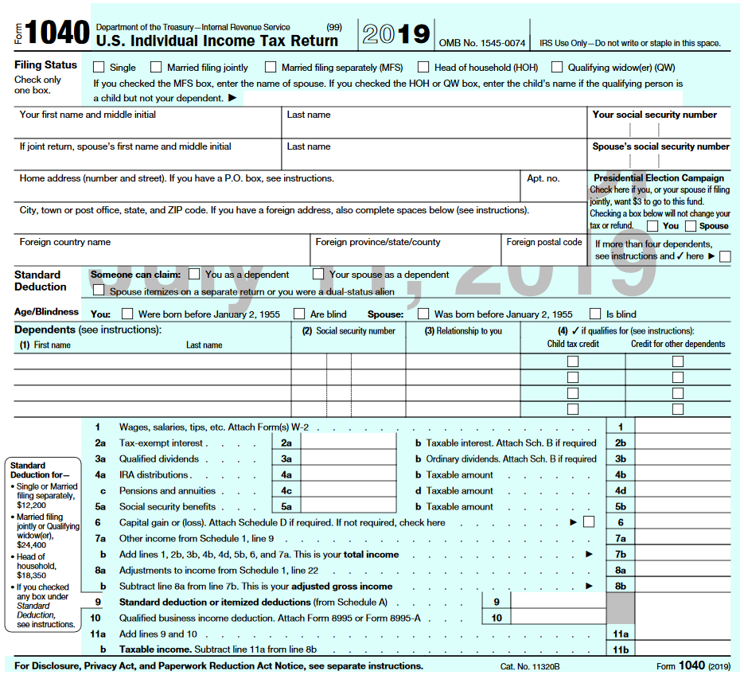

Draft version of 2019 Form 1040, front

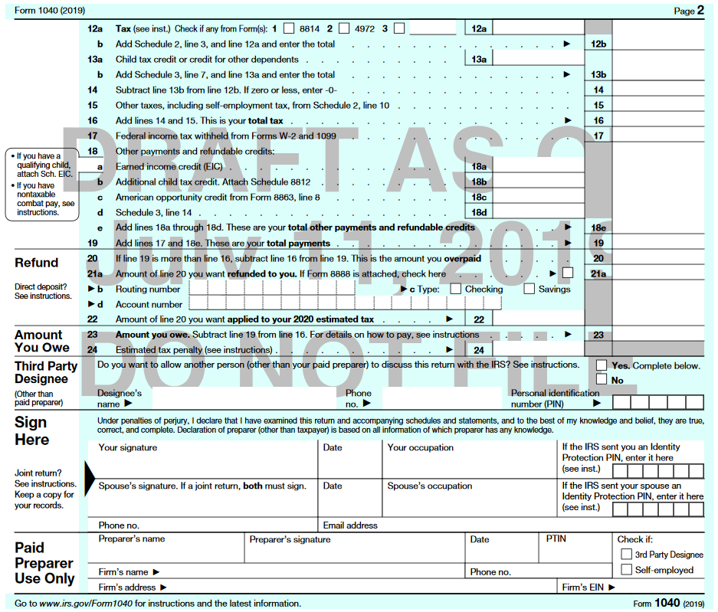

Draft version of 2019 Form 1040, back

(For purposes of comparison, the 2018 version of Form 1040 is shown at the end of this article.)

The draft version of 2019 Form 1040 represents a partial return to the format of Form 1040 as it appeared prior to this year’s tax season. The new Form 1040 takes up about three-quarters of a page, as contrasted to the half-page format of the 2018 Form 1040. The calculation of taxable income has been moved from the second page of Form 1040 back to the front page of the form, while the signature lines have been shifted from the front page of Form 1040 back to the second page. Additionally, the IRS proposes to eliminate three of the six main supporting schedules for Form 1040. (Much of the information reported on 2017 Form 1040 was moved to these supporting forms (Schedules 1-6) for 2018, not necessarily simplifying the task of tax preparation for filers with more complex tax situations.)

In addition to making Form 1040 somewhat larger and more legible, the proposed changes would also make it easier for taxpayers to spot the contributions of IRA income and of capital gains to total taxable income.

IRA, Pension, and Annuity Income. While individual retirement accounts (IRAs), pensions, and annuities are all financial vehicles for providing retirement income on a tax-deferred basis, these vehicles differ significantly from one another in terms of the rules that apply to eligibility, contributions, distributions, as well as to determining the tax-exempt status of the income generated by these retirement vehicles. Perhaps in acknowledgment of those differences, the 2017 Form 1040 contained separate lines for reporting IRA income (Lines 15a and 15b) and pension and annuity income (Lines 16a and 16b). The 2018 Form 1040, on the other hand, lumped all three types of income lumped together on the same set of lines (Lines 4a and 4b). The IRS proposes to revert to reporting IRA income separately from pension and annuity income on the 2019 Form 1040 (Lines 4a and 4b and Lines 4c and 4d, respectively).

Capital Gains and Losses. Though reported by a minority of taxpayers. capital gains are nevertheless a relatively common form of income: approximately 14 percent of the 150.3 million separate individual income tax returns filed with the IRS in 2016 – the most recent year for which figures are available – included capital gains or losses from the sale of stocks, bonds, personal residences, and other property reported on Schedule D, while it may be presumed that an equally large (or larger) group of taxpayers also reported capital gains distributions from mutual funds, which are not necessarily reported on Schedule D.

For the 2018 tax year, the IRS moved the line used to report capital gains and losses from Form 1040 itself to a new supporting form, Schedule 1. This change had the effect – intended or not – of obscuring the contribution of capital gains and losses to total taxable income, since Schedule 1 is also used to report such varied and often unrelated forms of income as rents, royalties, adjustments for refunds of previously deducted state and local taxes, and amounts received for services as an independent contractor. For 2019, the IRS proposes to disinter capital gains and losses from Schedule 1, and report capital gains/losses as a separate line item on Form 1040 (Line 6), as was done prior to the 2018 tax year.

For filers with relatively complex tax situations, the proposed reduction in the number of the main supporting schedules for 2019 Form 1040 from six to three will hopefully make the process of preparing their returns or looking up information on their completed returns a little less cumbersome next year. The main supporting schedules proposed for 2019 are compared with those for 2018 in the table below.

Principal Supporting Schedules for 2019 Form 1040 (Draft Versions) and 2018

2019 Supporting Schedules (Proposed) | 2018 Supporting Schedules | Remarks
Schedule 1, Additional Income and Adjustments to Income | Schedule 1, Additional Income and Adjustments to Income | IRS proposes to move the line item for capital gains/losses from Schedule 1 to Form 1040 for 2019.
Schedule 2, Additional Taxes | Schedule 2, Tax | - Combines content from 2018 Schedule 2 and 2018 Schedule 4.  - 2019 Schedule 2 will contain no line item for reporting the penalty under the health insurance mandate since this penalty has been repealed.
Schedule 3, Additional Credits and Payments | Schedule 3, Nonrefundable Credits | Combines content from 2018 Schedule 3 and 2018 Schedule 5.
– | Schedule 4, Other Taxes | Content of 2018 Schedule 4 combined with that of 2018 Schedule 2 for 2019. The new combined schedule is to be known as Schedule 2, Additional Taxes.
– | Schedule 5, Other Payments and Refundable Credits | Content of 2018 Schedule 5 combined with that of 2018 Schedule 3 for 2019. The new combined schedule is to be known as Schedule 3, Additional Credits and Payments.
– | Schedule 6, Foreign Address and Third Party Designee | IRS proposes to move the lines for entering contact information for third-party designees from Schedule 6 to Form 2019 for 2019.

Two pending or proposed changes to the line items contained in the main supporting schedules for Form 1040 warrant further comment:

Alimony. Among the many other changes made to the federal tax laws by the Tax Cuts and Jobs Act of 2017 (TCJA), this legislation exempted alimony received from taxation, while also eliminating the deduction for alimony paid in all cases where the alimony was received or paid pursuant to a divorce or separation agreement executed after December 31, 2018. To make it clearer whether alimony payments are still subject to tax or eligible for a deduction, the IRS proposes to require that filers enter the date of the original divorce or separation agreement on Schedule 1, Line 2b (for alimony received) or Schedule 1, Line 18c (for alimony paid).

Health Insurance Mandate. The TCJA also eliminated the mandate that individuals obtain health insurance coverage or pay a financial penalty for tax years beginning after December 31, 2018. Accordingly, the line on which filers must report an individual responsibility payment for those months during the tax year when they lacked health insurance coverage and for which they also did not claim an exemption will be eliminated (2018 Form 1040: Schedule 4, Line 61).

The content of the three main supporting schedules proposed for 2019 Form 1040 is summarized in the table below.

Supporting Schedules for 2019 Form 1040 (Draft Versions)

Form | Major Items Reported
Schedule 1, Additional Income and Adjustments to Income | Additional income:  - Business income (Schedule C)  - Partnership income (Schedule E)  - Farm income (Schedule F)  - Gains or losses from sales of business property (Form 4797)  - Alimony received  - Amounts received for services performed as an independent contractor  Adjustments to income:  - Educator expenses  - Health savings account contributions (Form 8889)  - Student loan interest deduction  - Qualified retirement plan contributions made by self-employed individuals
Schedule 2, Additional Taxes | - Alternative minimum tax (Form 6251)  - Repayments of excess advance premium tax credits (Form 8962)  - Tax on unearned income of children or dependents (“kiddie tax,” Forms 8615 or 8814)  - Self-employment tax (Schedule SE)  - Additional Social Security or Medicare taxes (Forms 4137, 8919, or 8959)  - Taxes on early distributions from, or excess contributions to, IRAs and other qualified retirement plans (Form 5329)  - Affordable Care Act penalty  - Household employment taxes  (Schedule H)  - Net investment income tax (Form 8960)

Form | Major Items Reported
Schedule 3, Additional Credits and Payments | Nonrefundable credits:  - Foreign tax credit (Form 1116)  - Child and dependent care credits (Form 2441)  - Education credits (Form 8863)  - Retirement savings contributions (Form 8880)  Other payments/refundable credits:  - Estimated 2019 tax payments  - Overpayment of income tax carried forward from 2018 return  - Affordable Care Act premium tax credit (Form 8962)  - Amount paid with tax extension request

The IRS is soliciting public comments on the draft versions of 2019 Form 1040 and Schedules 1-3, which may be submitted to WI.1040.Comments@IRS.gov through August 15, 2019.

Although the new tax form for seniors, Form 1040-SR, was mandated by the Bipartisan Budget Act of 2018, enacted in February 2018, congressional support for the creation of a federal income tax form for individuals aged 65 and older goes back at least as far as the bipartisan Seniors Tax Simplification Act, which was introduced by Senators Marco Rubio (R-FL) and Bill Nelson (D-FL) in March 2013. One practical consideration behind the proposal to create a simplified tax form for seniors – an idea that had the backing of the American Association of Retired Persons (AARP), as well as of the National Taxpayers Union – was that, although many retirees had moderate incomes and a simple financial situation, taxpayers aged 65 or older were not eligible to use Form 1040-EZ, the simplified tax form for low- and moderate-income taxpayers with basic tax situations.

Form 1040-SR is to be available to all taxpayers who turned 65 during the tax year, regardless of whether they are retired or still working. (On the other hand, retired individuals who have not yet turned 65 must use Form 1040.) A draft version of 2019 Form 1040-SR is shown below. Note this form is substantially identical to the draft version of 2019 Form 1040, except that Form-SR has larger type and also features a chart that the taxpayer can use to determine the amount of his or her standard deduction.

As is the case for the draft version of 2019 Form 1040, the IRS is requesting public comments on the draft versions of 2019 Form 1040-SR, which can be sent to WI.1040.Comments@IRS.gov through August 15, 2019.

To offer some concluding comments, although the goal of creating a simple, user-friendly Form 1040 has still not been achieved, the draft versions of 2019 Form 1040 and 2019 Form 1040-SR that the IRS released for public comment on July 11, 2019 are steps in the right direction. While the
2018 version of Form 1040, shown below, represented an attempt to provide filers with a tax
return the size of a postcard, the form arguably sacrificed clarity of the sake of brevity. The draft
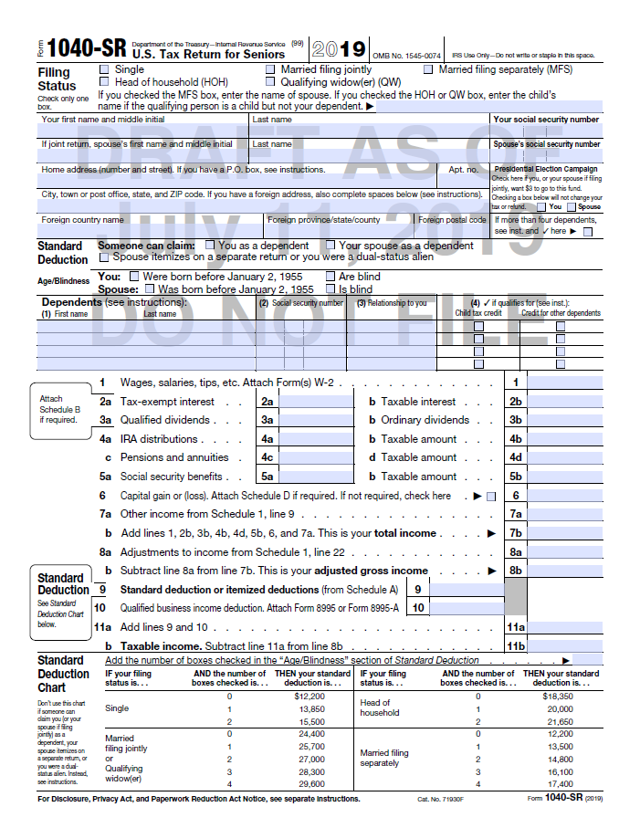
Draft version of 2019 Form 1040-SR, front

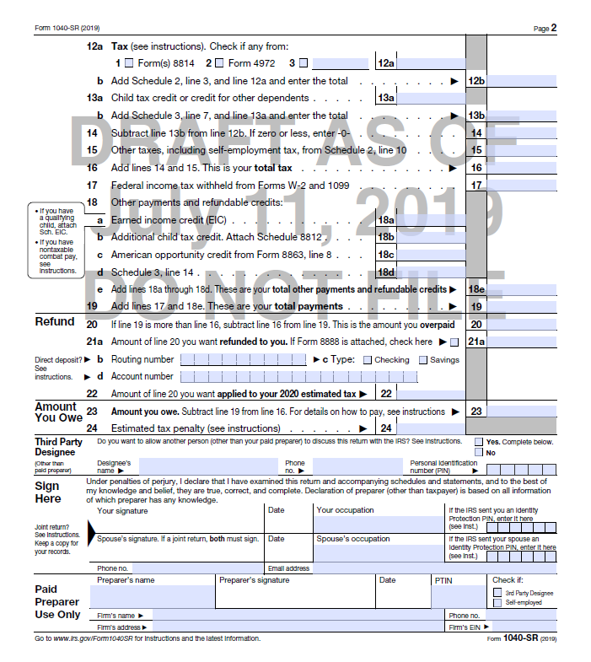
Draft version of 2019 Form 1040-SR, back

versions of 2019 Form 1040 and 2019 Form 1040-SR, on the other hand, are both less cramped than 2018 Form 1040, taking up three-quarters of a page and almost a full page on each side, respectively. With its larger type, 2019 Form 1040-SR is also much easier to read. In addition, the restoration of the separate line items for IRAs and capital gains on Form 1040 and Form 1040-SR makes the income information presented on these forms much more intelligible and easier to follow.
This leaves us with the following question: since the currently draft version of Form 1040-SR comes closest to the goal of representing a legible, intelligible tax form, why not offer this form to everybody? It was certainly laudable for Congress to demonstrate concern for the tax needs of senior citizens, as it did when it directed the IRS – through the Bipartisan Budget Act of 2018 – to create Form 1040-SR last year. However, for a variety of reasons, offering a separate version of Form 1040 solely for the use of individuals aged 65 and over seems problematic. As reflected by the fact that many older baby boomers – who began turning 65 back in 2011 – are still in the workforce, and also remain active participants in society, technology, and the culture, it is quite conceivable that many of them will decline to self-identify as “seniors,” and continue to fill out the version of Form 1040 used by everybody else, instead. Others may balk at the idea of being part of a demographic group that has been singled out for special treatment – however well-intentioned the reasons – by the IRS. Finally, one might wonder whether, instead of expending resources on maintaining Form 1040-SR as a separate tax form, those resources couldn’t be put to better use on programs promoting literacy in the areas of taxation, personal finance, and technology among underserved populations.

Edward Frede is a staff accountant at Gelman & Pelesh, P.C., a full-service accounting, tax, and advisory firm based in Springfield, PA.

2018 Form 1040

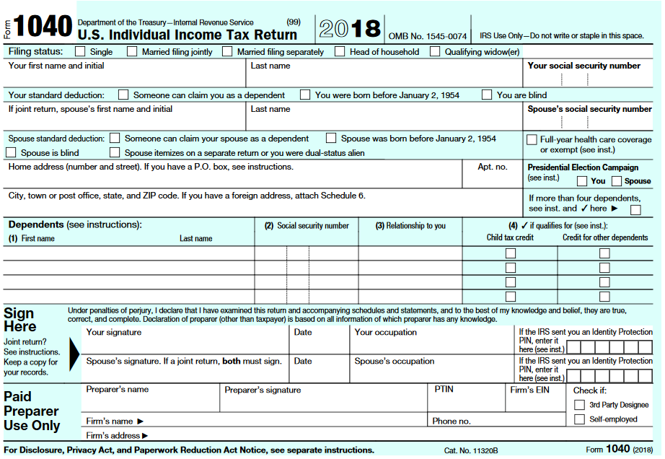

2018 Form 1040, front

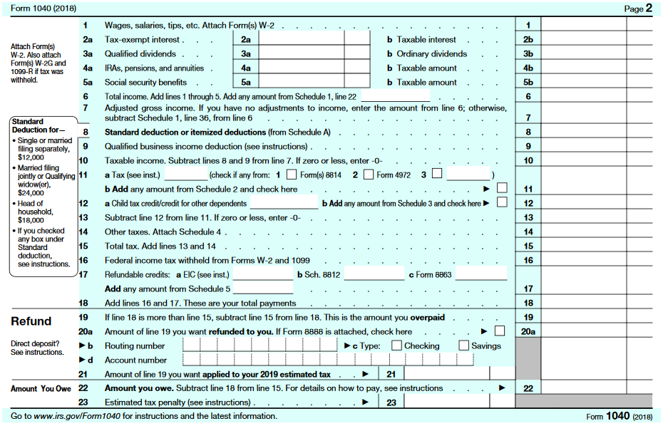

2018 Form 1040, back

